Write a PLSQL program using control statement to generate a progress report for the student.

(a)with table

declare

grade number(20);

begin

select student.sub1_marks into grade from student where student.std_id=103;

if grade>90 then dbms_output.put_line('out standing');

elsif grade>80 then dbms_output.put_line('distinction');

elsif grade>70 then dbms_output.put_line('good grade');

elsif grade>60 then dbms_output.put_line('first class');

elsif grade>50 then dbms_output.put_line('second class');

elsif grade<50 then dbms_output.put_line('fail');

end if;

end;

/

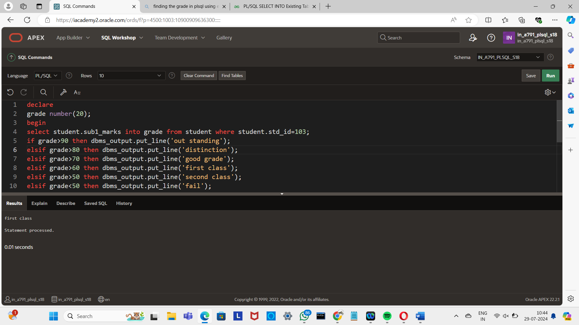

(b) without table

declare

m1 number:=98;

m2 number:=90;

m3 number:=82;

av number(10,2);

begin

av:=(m1+m2+m3)/3;

if av>90 then dbms_output.put_line('Out standing');

elsif av>80 then dbms_output.put_line('Distinction');

elsif av>70 then dbms_output.put_line('Good Grade');

elsif av>60 then dbms_output.put_line('First class');

elsif av>50 then dbms_output.put_line('Second class');

elsif av<50 then dbms_output.put_line('Fail');

end if;

end;

/

